AI-Powered Health Monitoring System

Name: Kariuki Naomi

UN SDG: Goal 3 – Good Health and Well-being

This project uses AI to monitor health metrics in real time. Using wearable device data, we detect anomalies that may indicate early signs of health issues.  
The system is built with Python, Flask, and an Isolation Forest model trained on simulated health data.

# Health Metrics Used

- Heart Rate

- Blood Oxygen Level

- Sleep Quality (Hours)

- Step Count

- Stress Level

# AI Model: Isolation Forest

We use an unsupervised learning algorithm (Isolation Forest) to detect outliers in real-time health data.  
Outliers may represent abnormal physiological states and prompt alerts or recommendations.

# Sample Data and Anomaly Detection

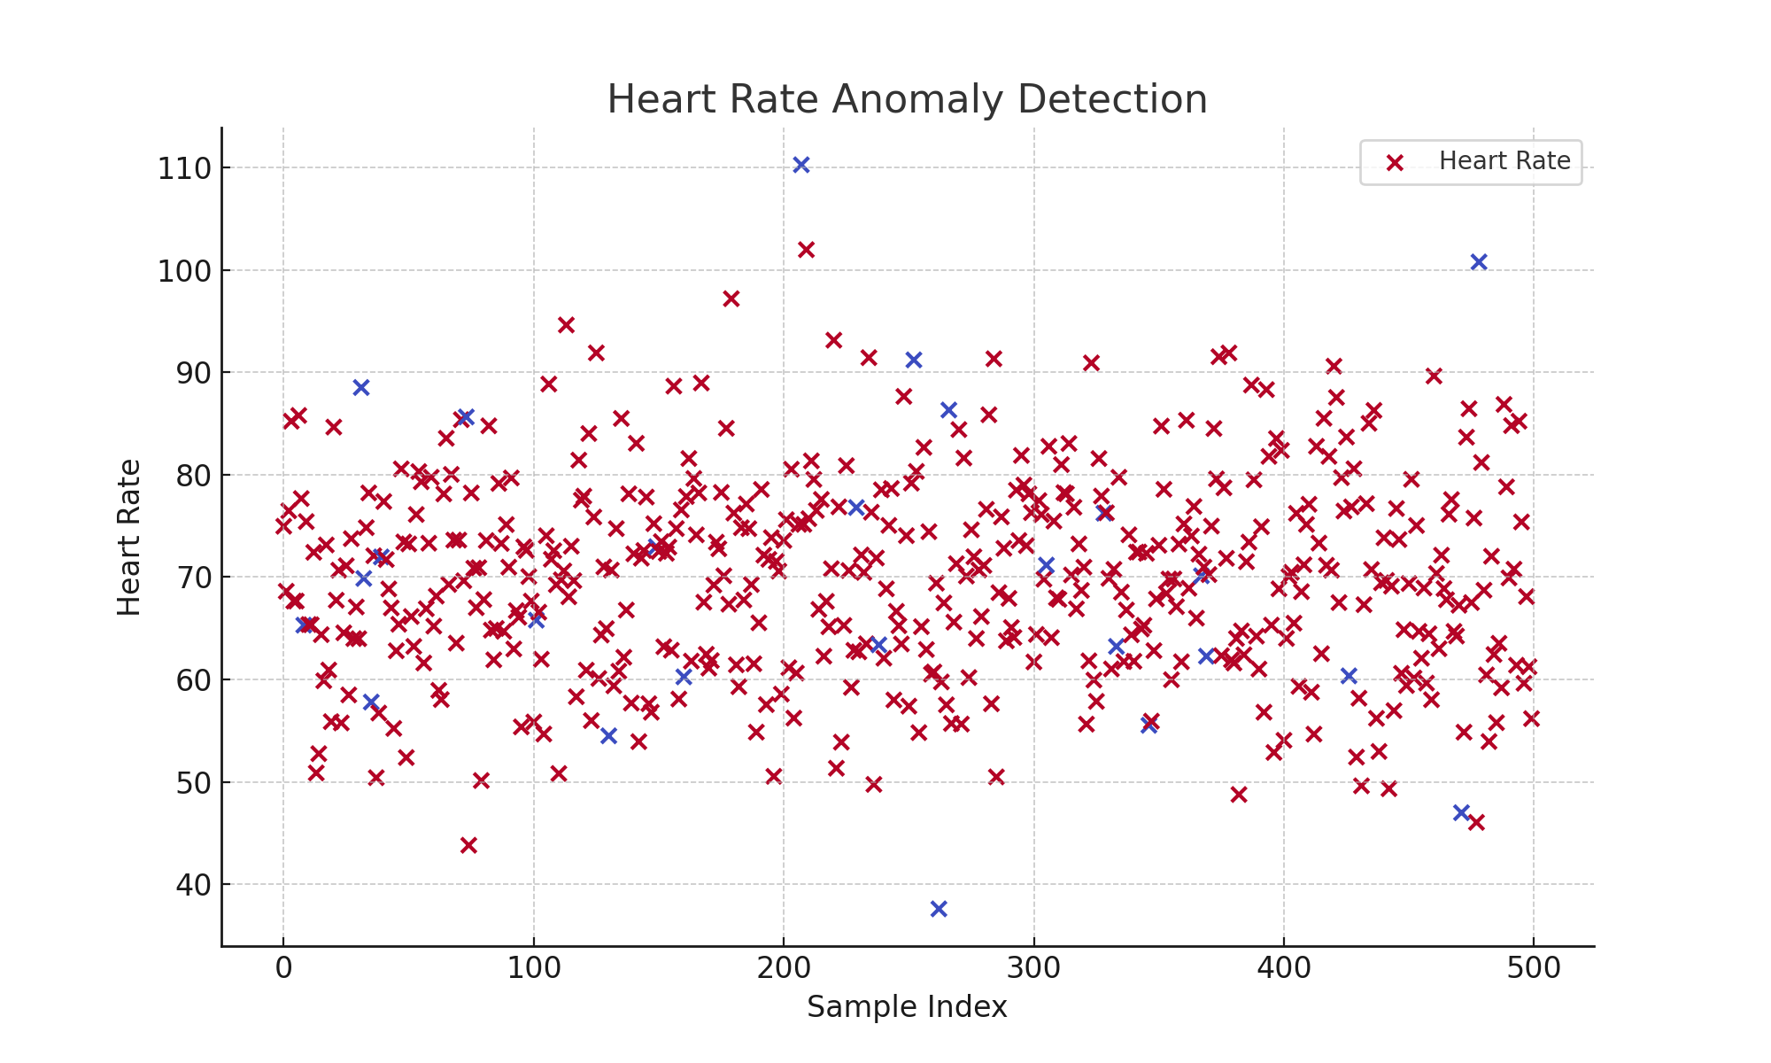

# Impact & SDG Alignment

The system promotes early health issue detection, improved patient monitoring, and personalized recommendations,  
contributing to SDG 3 by reducing premature mortality and improving well-being.